Lawrence Township Celebrates Juneteenth
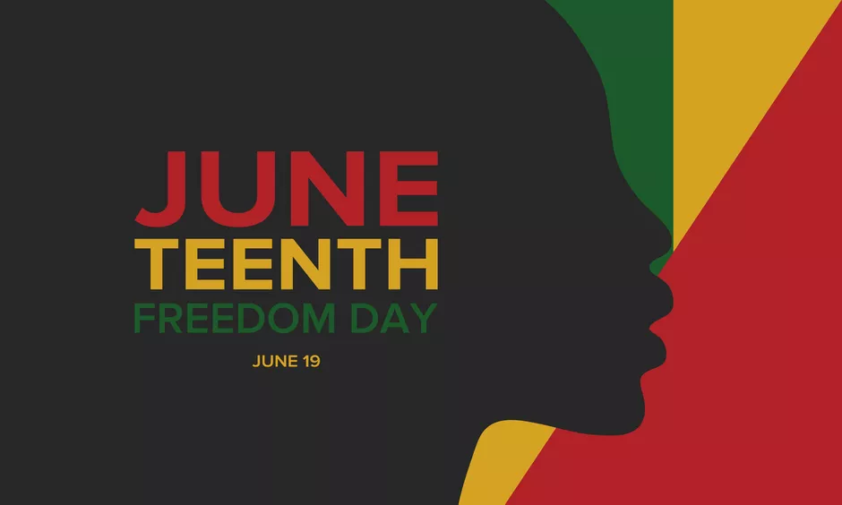

Juneteenth celebrations highlight the transformation of the United States into a nation living out the creed of liberty and justice for all. The delayed liberation of slaves in Texas after the Civil War highlights the nation’s challenges with racial inequity. Celebrating Juneteenth allows our nation to face the injustices of the past and celebrate collectively the emancipation and freedom of African Americans. Our nation is comprised of all races, creeds, and cultures. Equality can only be obtained through embracing diversity and inclusionary social practices for all.

Since the 1860’s Black communities across the United States have held annual Juneteenth celebrations; family and community are a central part of such celebrations. In recent times, Juneteenth celebrations include community picnics, parades, and other celebrations. Juneteenth has also been a day of communal rest and recuperation following anti-Black police violence, discrimination, and other barriers to equality.
The national celebration of Juneteenth continues to shed light on the inequity that members of the African American community face on a daily basis. These inequities range from healthcare to socioeconomical and educational disparities. Within the past two years, our country has witnessed several historical civil rights cases highlighted through national media attention. One of the most notable cases has been the murder of George Floyd. The recognition of Juneteenth demonstrates that such social injustices, racial hatred and biases will no longer be ignored and this day serves as a global precursor to acknowledging systemic inequality. Celebrations are not relegated to only African-American communities. Juneteenth is globally recognized as a day of liberation and freedom for all people. New Jersey is one of many states to recognize Juneteenth as a holiday. In September of 2020, Governor Phil Murphy signed legislation observing the 3rd Friday in June as a State and public holiday.

To honor this significant event, several educational programs activities and celebrations are occurring throughout New Jersey. For your convenience, below are links identifying some events to celebrate this historic day symbolizing freedom, justice and equality.

Educational Resources:
https://nationaltoday.com/juneteenth/

Governor Murphy Signs Legislation Designating Juneteenth as a State and Public Holiday
https://www.nj.gov/governor/news/news/562020/20200910b.shtml

Video’s links explaining the history of Juneteenth and slavery leading up to Juneteenth.
https://nmaahc.si.edu/sites/default/files/images/juneteenthresources_final.pdf
https://nmaahc.si.edu/blog-post/celebrating-juneteenth
https://nmaahc.si.edu/blog-post/historical-legacy-juneteenth
https://nmaahc.si.edu/events/juneteenth

National Parks Service:
Juneteenth - NPS Celebrates! (U.S. National Park Service)

